**Quiz 6 - Naive Bayes**

Consider using the dataset “bank-sample.csv” to predict whether a customer will subscribe to a bank’s services using a Naive Bayes model. Refer to the photo provided for all subsequent questions.

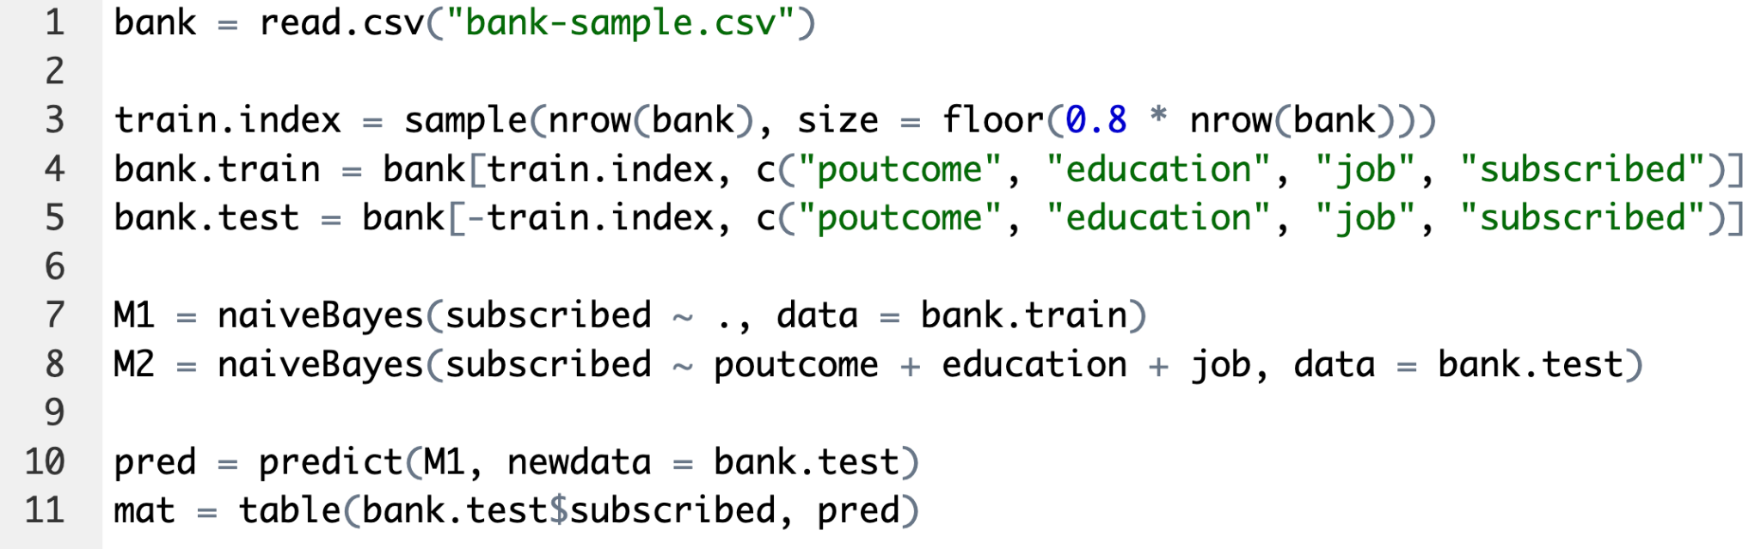

|  |  |
| --- | --- |
| **Question 1**  Which statement about the two models formed on lines 7 - 8 is true? | |
| A | Both models are identical |
| B | Both models contain the same number of explanatory features |
| C | M1 was trained with a smaller data set compared to M2 |
| D | M2 contains 4 explanatory features |

|  |  |
| --- | --- |
| **Question 2**  What does the object “pred” on line 10 contain? | |
| A | Predicted probabilities of subscribing for the testing data |
| B | Predicted probabilities of subscribing for the training data |
| C | Predicted class labels for the testing data |
| D | Predicted class labels for the training data |

|  |  |
| --- | --- |
| **Question 3**  Which of the following lines of code will output the predicted probabilities of subscribing the bank service for the testing data? | |
| A | predict(M1, newdata = bank.test) |
| B | predict(M1, newdata = bank.test, type = "prob") |
| C | predict(M1, newdata = bank.test, type = "class") |
| D | predict(M1, newdata = bank.test, type = "raw") |

|  |  |
| --- | --- |
| **Question 4**  Which line of code correctly calculates the accuracy of M1 using the confusion matrix formed on line 11? | |
| A | sum(diag(mat)) / sum(mat) |
| B | sum(mat) / sum(diag(mat)) |
| C | (mat[2] + mat[3]) / sum(mat) |
| D | (mat[1] + mat[3] / sum(mat)) |

|  |  |
| --- | --- |
| **Question 5**  True or False? Naive Bayes works best when the features are dependent on each other. | |
| A | True |
| B | False |